Press Release

Robotic and Cobot Workstations Help Manufacturers Achieve Greater Efficiency and Solve Worker Shortages

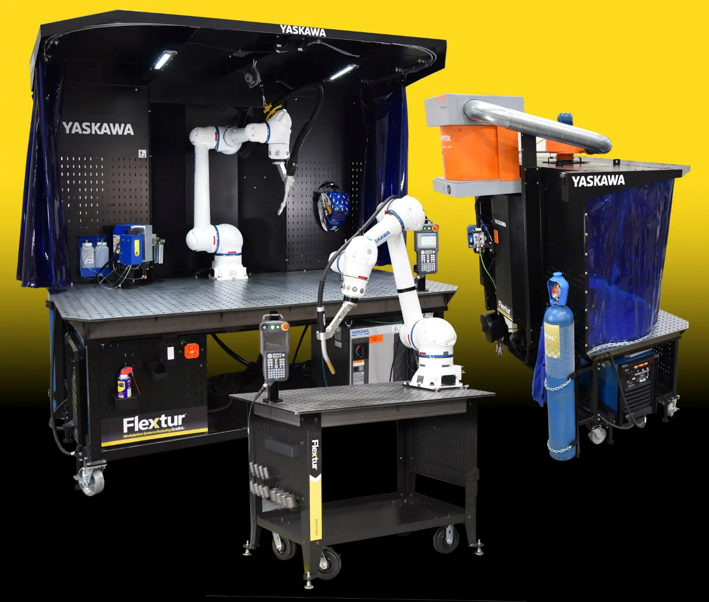

Dalton, Ohio (October 17, 2022)—Flextur announces the launch of its robotic and cobot workstations to help manufacturers achieve maximum efficiency. The workstations are available as a standard solution or custom engineered solution.

Robots and cobots are becoming more and more popular in manufacturing facilities as companies adopt automation and Industry 4.0 technologies. Robotic/Cobot technology integration alleviates challenges such as labor and skill shortages and replaces humans in mundane or repetitive tasks allowing them to be available for higher-values activities. Additionally, robots and cobots perform tasks faster and with greater strength, accuracy, and data capabilities.

To keep up with the increased production, organizations must utilize lean methodologies to create greater efficiencies and ensure consistent throughput when working with robots and cobots. This is especially important with cobots. Workstations should be set up with all of the proper tools and materials within reach to maintain efficiency and keep up with the cobot’s output.

“This new launch adds to the versatility of Flextur workstations. Our tables and carts are durable and stable enough to hold any robotic arm while also providing the opportunity to create a lean/5S workstation. Flextur is here to help our customers achieve maximum efficiency, greater production and throughput, and solve labor and skill shortages,” says Pioneer Corp CEO Daniel Wengerd.

Flextur partners with robotic and cobot manufacturers to develop workstations with existing robot systems and to create cobot stations with a Flextur table or cart to anchor the cobot arm. Some of Flextur’s current automation partners are Yaskawa, OTC, KC Robotics, as well as many others.

To find out more about Flextur Robotics and Cobot solutions, visit website or call 877.435.3988.

Contact for Journalists:
Doug Scheetz, Director of Marketing
Phone: 330.516.1367
Email: dougs@pioneercorp.us

Flextur™, a brand owned by Pioneer®, offers innovative new lean and 5S workflow solutions developed out of its own Lean journey, including Gridlok™ and other products like weld tables, workstations, work carts, workbenches, and pack stations. Flextur products meet Lean specifications and are simple, versatile, durable, and affordable. Flextur solutions improve workflow, efficiency, throughput, and organization for businesses. Flextur comes from a 40-year history of delivering innovative, quality products and elite customer service. All products are made in the USA. https://www.flexturusa.com/

